**Summary:**

To recreate the network topology we established in class, and test our knowledge of common networking commands.

**Topology:**

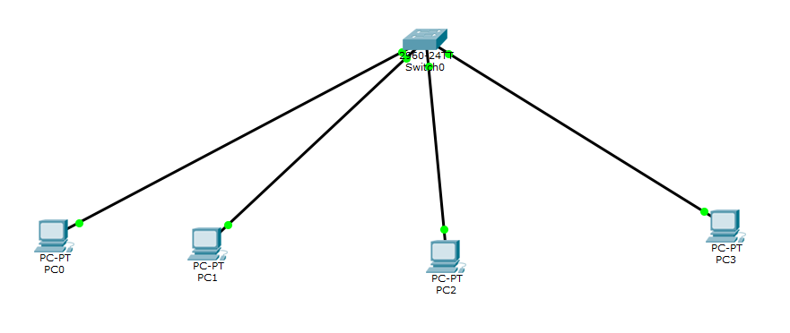

**Commands:**

|  |  |  |
| --- | --- | --- |
| Ipconfig: | Display network configuration for each network adapter |  |
| Ipconfig /all: | More extensively displays the network configuration for each network adapter in greater detail |  |
| Ping: | Sends echo messages, used to test whether the host computer has a connection to the target device. |  |
| Tracert: | Traces the route that a packet takes to its destination |  |

**Conclusion:**

To my knowledge the network setup in Cisco Packet Tracer functions similarly with the network establish in the class room. All the command prompt commands worked and returned the desired feedback without the need of extensive configuration.